**Determine and List Entities**

Entities:

Customers

Distributors

Movie Copies

Movies

Rentals

Purchases

Acting Roles

Directing Roles

Academy Awards

Catalogs

Catalog Items

Items Purchased

Attributes:

Customers

1. Customer ID (PK)
2. Name
3. Address
4. Phone Number
5. E-mail

Distributors

1. Name (PK)
2. Phone Number
3. E-mail
4. Quantity Discount Offered
5. Repeat Customer Discount Offered

Movie Copies

1. Copy ID (PK)
2. Movie ID (FK)
3. Purchase ID (FK)
4. Distributor Serial Number
5. Movie Format
6. Rental Cost

Movies

1. Movie ID (PK)
2. Name
3. Genre
4. Year Released
5. Rating
6. Length

Rentals

1. Rental ID (PK)
2. Customer ID (FK)
3. Copy ID (FK)
4. Rental Date
5. Due Date
6. Date Returned
7. Rental Overdue?
8. Rental Fee
9. Late Fee
10. Damage Fee
11. Failure to Rewind Fee
12. Other Fees
13. Taxes
14. Discounts Applied
15. Total Cost
16. Amount Paid
17. Amount Due

Purchases

1. Purchase ID (PK)
2. Distributor Name (FK)
3. Base Cost
4. Quantity Discounts Applied
5. Returning Customer Discounts Applied
6. Taxes
7. Final Purchase Cost

Acting Roles

1. Role ID (PK)
2. Movie ID (FK)
3. Actor/Actress Name
4. Character Name
5. Role Award ID (FK)

Directing Roles

1. Role ID (PK)
2. Movie ID (FK)
3. Director Name
4. Role Award ID (FK)

Academy Awards

1. Award ID (PK)
2. Movie ID (FK)
3. Award Name

Catalogs

1. Catalog ID (PK)
2. Distributor Name (FK)
3. Issue Date

Catalog Items

1. Item ID (PK)
2. Catalog ID (FK)
3. Item Name
4. Item Format
5. Item Cost

Items Purchased

1. Item Purchase ID (PK)
2. Item ID (FK)
3. Purchase ID (FK)

**Relationship Sentence Pairs**

Each customer is involved in one or more rentals

Each movie copy is involved in one or more rentals

Each movie has one or more movie copies

Each purchase involves one or more movie copies

Each distributor was involved in one or more purchases

Each movie has one or more acting roles

Each movie has one or more directing roles

Each movie has zero or more Academy Awards

Each Academy Award can involve zero or more winning acting roles (if acting award)

Each Academy Award can involve zero or more winning directing roles (if directing award)

Each distributor has one or more catalogs

Each catalog has many catalog items

Each catalog item may be involved in zero or more item purchases

Each purchase involves one or more items purchased

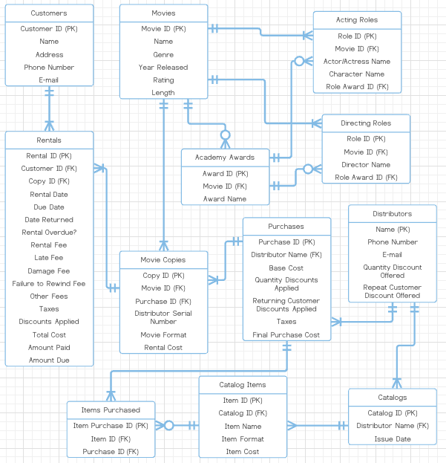

**Spreadsheet Page 1**

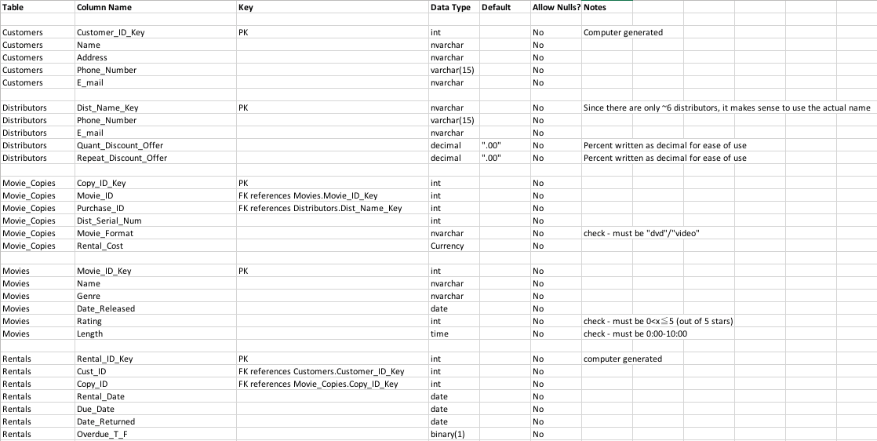

**Spreadsheet Page 2**

